Scott River Coho Salmon Spawning Ground Surveys
2020-2021 Season
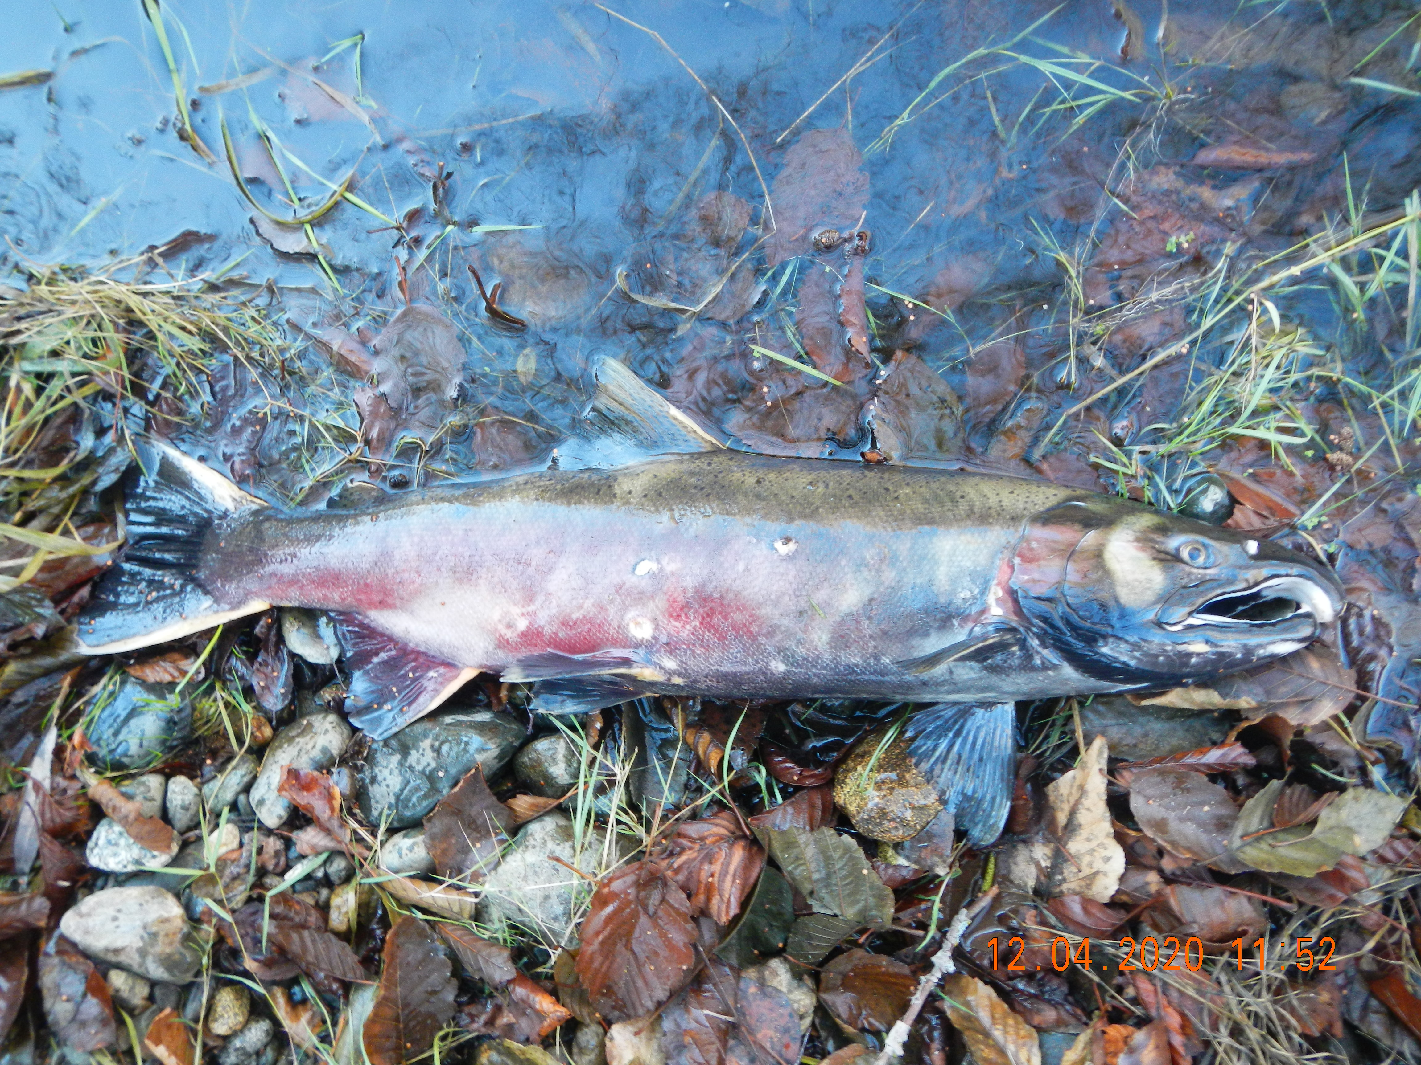

Report Prepared by Chris Voigt
Siskiyou Resource Conservation District

United States Fish and Wildlife Service – Fisheries Program
Agreement # F20AP11407

December 2021

Siskiyou Resource Conservation District – P.O. Box 268 Etna, CA 96027
(530) 467-3975
www.siskiyourcd.com

ABSTRACT

The Scott River Fish Counting Facility operated by the California Department of Fish and Wildlife located at river mile 18.2 recorded 1,754 live adult coho migrating upstream into the Scott Valley from November 15th, 2020, to January 4th, 2021 (Knechtle and Giudice, 2021). Following a critically dry 2019-2020 water year in the Scott Valley sub-basin of the Klamath River, streams throughout the watershed exhibited historically low water levels through mid-November 2020. As a result of historic drought conditions, the Scott River remained disconnected throughout the valley until Mid-December. Reach 9, between the confluence with Oro Fino Creek and Meamber Bridge, was the last valley section of the Scott River to connect. Spawning ground surveys were conducted by the Siskiyou Resource Conservation District from November 25th, 2020, to January 22nd, 2021, to determine the distribution of coho salmon spawning in the watershed and inform related management decisions over the following year. A total of 20.5 river miles were surveyed (12.5 river miles on the mainstem and 8.0 river miles on western tributaries). Surveys were conducted sequentially, as conditions allowed, through the active period of the run, and consisted of trained two-person field crews hiking established reaches either in-stream or along the bank in waders. Field technicians counted the number of live fish by species, documented the location and dimensions of redds, and collected biological samples (scale, tissue, and otolith) from recovered carcasses. A total of 280 coho redds were recorded by surveyors on the Scott River mainstem and the following tributaries (from north to south): Shackleford Creek and its tributary Mill Creek, French Creek and its tributary Miners Creek. A total of 78 coho carcasses were recovered, sexed, measured, and sampled.

TABLE OF CONTENTS
ABSTRACT 2
TABLE OF CONTENTS 3
ACKNOWLEDGEMENTS 4
INTRODUCTION 5
Project Purpose and Objectives 5
Study Location and Run Timing 6
Water Year Conditions 6
Coho Population Trends in the Scott River Watershed 7
METHODS 8
Reaches Surveyed 9
Crew Training 10
Survey Timing 10
GPS Data Collection 10
Sample Collection 11
Species, Gender and Origin Identification 12
RESULTS 12
Flow Conditions and Access, Run Abundance and Timing 12
Carcasses 13
Redds 16
DISCUSSION AND CONCLUSIONS 21
Recommendations 22
REFERENCES 22
Appendix I: Length of Stream Reaches Surveyed 24
Appendix II: List of Coho Surveys Completed 25

ACKNOWLEDGEMENTS

The following entities cooperated in the Scott River survey effort:

California Department of Fish and Wildlife
Scott River Watershed Council
Quartz Valley Indian Tribe
National Marine Fisheries Service

The Siskiyou Resource Conservation District was funded by the United States Fish and Wildlife Service, Fisheries Program, through Agreement F20AP11407.

Siskiyou RCD staff that participated in the 2020-21 field surveys:

Chris Voigt, Lead Field Technician
Evan Senf, Field Technician

The Siskiyou RCD would like to extend a specific acknowledgement to all the participating Scott Valley landowners that gave permission for field technicians to conduct surveys on their property. This work would not have been completed without their cooperation.

INTRODUCTION

Coho salmon (Oncorhynchus kisutch) are endemic to the Scott River system and belong to the Southern Oregon Northern California Coast (SONCC) Evolutionarily Significant Unit, which was listed as threatened under the Federal Endangered Species Act (by the National Marine Fisheries Service) in 1997. In 2001, the State of California began considering listing coho salmon as threatened and, with the expectation of an abundant run on the Scott River, the Klamath National Forest spearheaded the first spawning ground survey effort (Maurer, 2002). The spawning ground surveys began as a cooperative effort among local landowners, agencies and concerned volunteers. At that time, it was recognized that baseline population and distribution data was needed in order to implement and assess effective restoration plans and efforts. In 2004, the California Fish and Game Commission acted to add coho salmon to the state endangered and threatened species list and the threatened listing became effective March 5th, 2005. The collection of coho spawning distribution data has continued annually on the Scott River since the initiation of the surveys in 2001.

In addition to the spawning ground surveys, coho population data (run size and timing) has been gathered since 2007 at the Scott River Fish Counting Facility (SRFCF) run by the California Department of Fish and Wildlife (CDFW). The counting station is operated during the Chinook and coho salmon migration period and consists of a temporary weir constructed at river mile 18.2 that directs fish through a video flume where they are counted by species. This video weir data is coupled with downstream mark and recapture population estimates completed during the spawning ground surveys to make an escapement determination for the Scott River.

The monitoring of coho spawning parameters (abundance, range, distribution, and timing) through annual surveys and operation of the SRFCF is valuable on both an annual basis and for long-term trend analysis. By locating known coho spawning sites, stream reaches can be identified where juvenile coho salmon may be rearing the following summer when low-flow conditions may impact growth and survival. The Scott River Water Trust, a nonprofit that seeks to voluntarily improve stream flow in critical stream reaches, relies on this information each year to prioritize water leases. Over the long-term, this distribution data has allowed for the development of strategic recovery plans as well as the design, implementation, and assessment of informed restoration projects across the Scott River watershed.

Project Purpose and Objectives

The purpose of the annual spawning ground surveys is to gather data on run parameters including the abundance, timing, duration, age composition, hatchery contribution and redd distribution of coho salmon in the Scott River and its tributaries. The 2020-2021 effort marks the twentieth consecutive year of data collection (although there was no valley wide data collection during 2017-18 and 2018-19 runs).

Specific project objectives:

- Conduct cooperative coho salmon spawning ground surveys on the Scott River and tributaries during the 2020-2021 survey season to document the distribution of coho salmon spawning within the historic range.
- Attempt to document the upper extent of spawning in each tributary where coho are found.
- Collect biological samples from carcasses to build upon our understanding of the life history of the evolutionarily significant SONCC coho salmon and to compare the genetic relationship between Scott River fish and other stocks.
- Inform local non-governmental organizations and community members of potential locations were juvenile coho may be rearing for the purpose of informed management over the following summer.

Study Location and Run Timing

The 2020-2021 survey effort took place in the Scott River Watershed, a sub-basin of the Klamath River Basin. The Scott River is a major tributary and enters the Klamath River at river mile 143 in Siskiyou County, California. Coho salmon (Oncorhynchus kisutch) generally return to the Scott River to spawn from mid-October to early January with the Chinook salmon (Oncorhynchus tshawytscha) and steelhead trout (Oncorhynchus mykiss) runs overlapping (mid-September through late December and November through April, respectively).

Water Year Conditions

Following an average 2019 water year in the Scott Valley sub-basin of the Klamath River, the 2020 water year was notably dryer than the previous year and the historical average. Precipitation at the Fort Jones weather station was only 37% of the recorded average (47-year dataset). Precipitation levels as of April 1st and for the full water year were 38% and 37% of normal, respectively. In the spring of 2020, the Scott River basin snowpack was found to be less than half of recorded averages at 43-47% on April 1st and exceedingly low at 8% on May 1st (49-year dataset). The lack of precipitation and snowpack were reflected in Scott River discharge, which tracked much less than the 79-year historic median daily discharge from approximately January 2020 through July 2020. As a result of these factors, river discharge exhibited a relatively rapid decline, with summer minimum discharge of approximately 10 cubic feet per second (cfs). Thus, the Scott River was disconnected through the valley during the base flow period of Mid-July through September. Using the water year classification methodology developed by the Scott River Water Trust, Water Year 2020 has been classified as a “Critically Dry Year”.

The connectivity of the Scott River in the valley is critically important for spawning to occur, and the timing of reconnection may dictate when and where fish can spawn. Scott River connectivity conditions proceeded as follows:
- A Siskiyou RCD employee visually confirmed connectivity of Shackleford Creek to the Scott River on November 15th 2020. Shackleford may have disconnected intermittently for a few days before a series of storms in mid-December recconnected Shackleford to the Scott River for the remainder of the spawning season.
- Siskiyou RCD employees visually confirmed connectivity through Reach 9 between the river’s confluence with Oro Fino Creek and the Meamber Bridge (over the Scott River) on November 15th, 2020. Connectivity through this reach is critical, as it allows salmonids access to the valley areas of the Scott River, including Miners and French Creeks.
- The Scott River connected in the tailings section of Reach 16 on January 4th, 2021, thereby connecting the entire reach and the river’s mainstem with the East Fork and South Fork of the Scott River. Ocean run salmon gained access to the entire reach 16 and many upper watershed tributaries at this time.
- Despite subsequent precipitation events, full connectivity with some tributaries of the Scott River did not occur. Patterson Creek and Kidder Creek did not maintain full connectivity with the Scott River during the timeframe of the spawning ground surveys. Sugar Creek, Miners/French Creeks and Mill/Shackleford Creeks remained connected to the Scott River throughout the remainder of the spawning season through January, 2021.

Spawning surveys began on November 25th, 2020, on Reach 9 of the Scott River (between the river’s confluence with Oro Fino Creek and the Meamber Bridge) and continued through January 22nd, 2021.

Mostly mild weather conditions during December and January provided good conditions for the surveys; however, two surveys (one on Mill/Shackleford Creeks and one on the South Fork Scott River) were cancelled due to high flows in mid-January, 2021, that made conducting surveys unsafe.

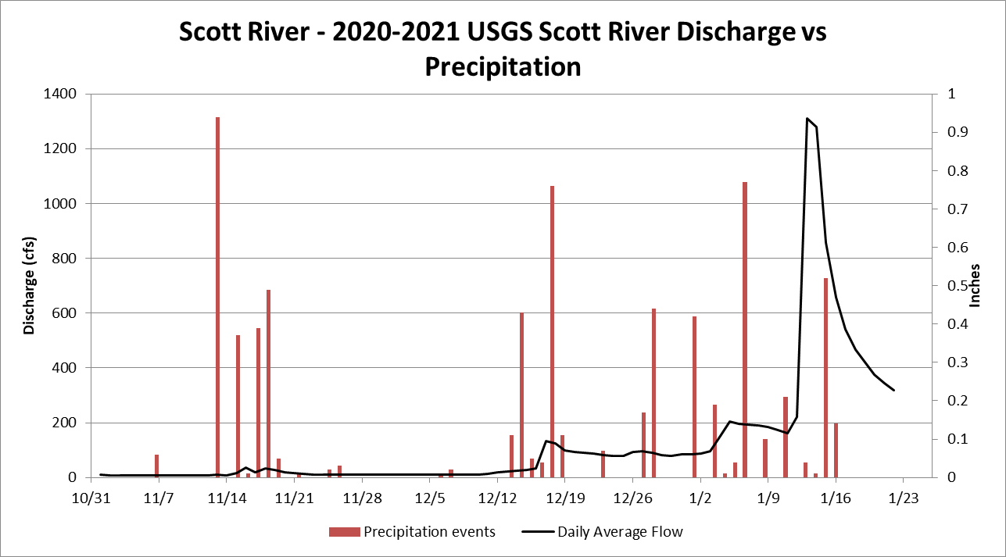
Figure 1: Scott River daily average discharge and daily accumulated precipitation – USGS Streamflow Gage RM 21 (USGS 2020, provisional data) and Callahan RAWS (Western Regional Climate Center, 2020)

Coho Population Trends in the Scott River Watershed

Annual monitoring of the quantity and distribution of Scott River coho salmon spawning began in 2001. Since that time, the surveys have enumerated between 6 and 960 redds per year (Table 1). It is important to note that surveys do not cover all potential spawning habitats and it is understood that these figures do not represent a total count of coho redds in the watershed. The survey effort has attempted to maintain coverage of consistent index reaches over the years, thus ensuring that the relative number of redds observed each year is comparable. This data, in combination with the yearling juvenile smolt emigration abundance data collected since 2000, had indicated a significant variation in brood year strength, with one of the three brood years being notably stronger (Jetter et al., 2016). Adult coho spawner escapement (by return year) has been estimated since 2007 and is predominantly derived from the SRFCF recordings, with adjustments made to account for spawning below the migrant weir. This data shows that adult returns to the Scott River have ranged from 63 to 2,752 fish, with an average of 645 adults (Table 1, Knechtle and Giudice, 2020). The brood year discussed in this report is comprised of the progeny of a return of 382 adult fish in 2017, which was a below average year for returns.

Table 1. Coho redds and abundance in the Scott River across all Brood Years (Magranet, 2017; Knechtle and Giudice, 2021).
Year | Total Redds Documented | Estimated Coho Spawner Escapement
2001* | 211 | ND
2002* | 17 | ND
2003 | 6 | ND
2004 | 960 | ND
2005 | 30 | ND
2006 | 9 | ND
2007 | 259 | 1,622
2008 | 24 | 63
2009 | 6 | 81
2010 | 162 | 927
2011 | 26 | 355
2012 | 24 | 201ª
2013 | 354^{b} | 2,752
2014 | 103 | 485
2015 | 60 | 212ª
2016 | 95 | 226ª
2017 | ND | 382
2018 | ND | 739
2019 | 79 | 346
2020 | 280 | 1766
Average | 150 | 725
* Survey reaches expanded in 2003, therefore data collected in 2001 and 2002 are not directly comparable
ª Abundance underestimated, high flows prematurely ended survey season
^{b} Superimposition of coho redds observed in all locations including with Chinook redds

METHODS

The Siskiyou RCD follows the protocol employed to assess Chinook populations in the Klamath River Basin since 1992. This protocol has been used in the Scott River watershed for adult coho spawning ground surveys since they were initiated in 2001 (Maurer, 2002). Stream reaches were surveyed by hiking the stream channel during the coho spawning season, from mid-November through January. Surveyors worked in teams of two (sometimes accompanied by the landowner), traversing the stream in neoprene waders and felt-soled boots, walking in a downstream direction. The number of live fish, redds and carcasses observed were enumerated by species, recorded on data sheets, and mapped for each stream surveyed. Redd dimensions and substrate composition information was collected from redds in situations where such activities did not disturb spawning fish. Flagging was hung on the bank adjacent to all newly identified redds to prevent double counting during subsequent surveys. GPS points were collected at redd sites, carcass sites, and sites of unusual fish observations (i.e. fish located beyond the previously documented extent of spawning). Tissue, scale, and otolith samples were taken from each recovered coho carcass for age and DNA analysis. All carcasses that had been sampled were chopped in half with a machete to signify that they had been handled and were promptly returned to the stream.

Reaches Surveyed

Coho spawning ground surveys were completed on 12.7 miles of the Scott River mainstem and 12.0 miles of the tributaries (Appendix I. Length of Stream Reaches Surveyed). Tributaries surveyed (from North to South) included: Mill & Shackleford Creeks, French & Miners Creeks, Sugar Creek, and South Fork Scott River (Map 1).

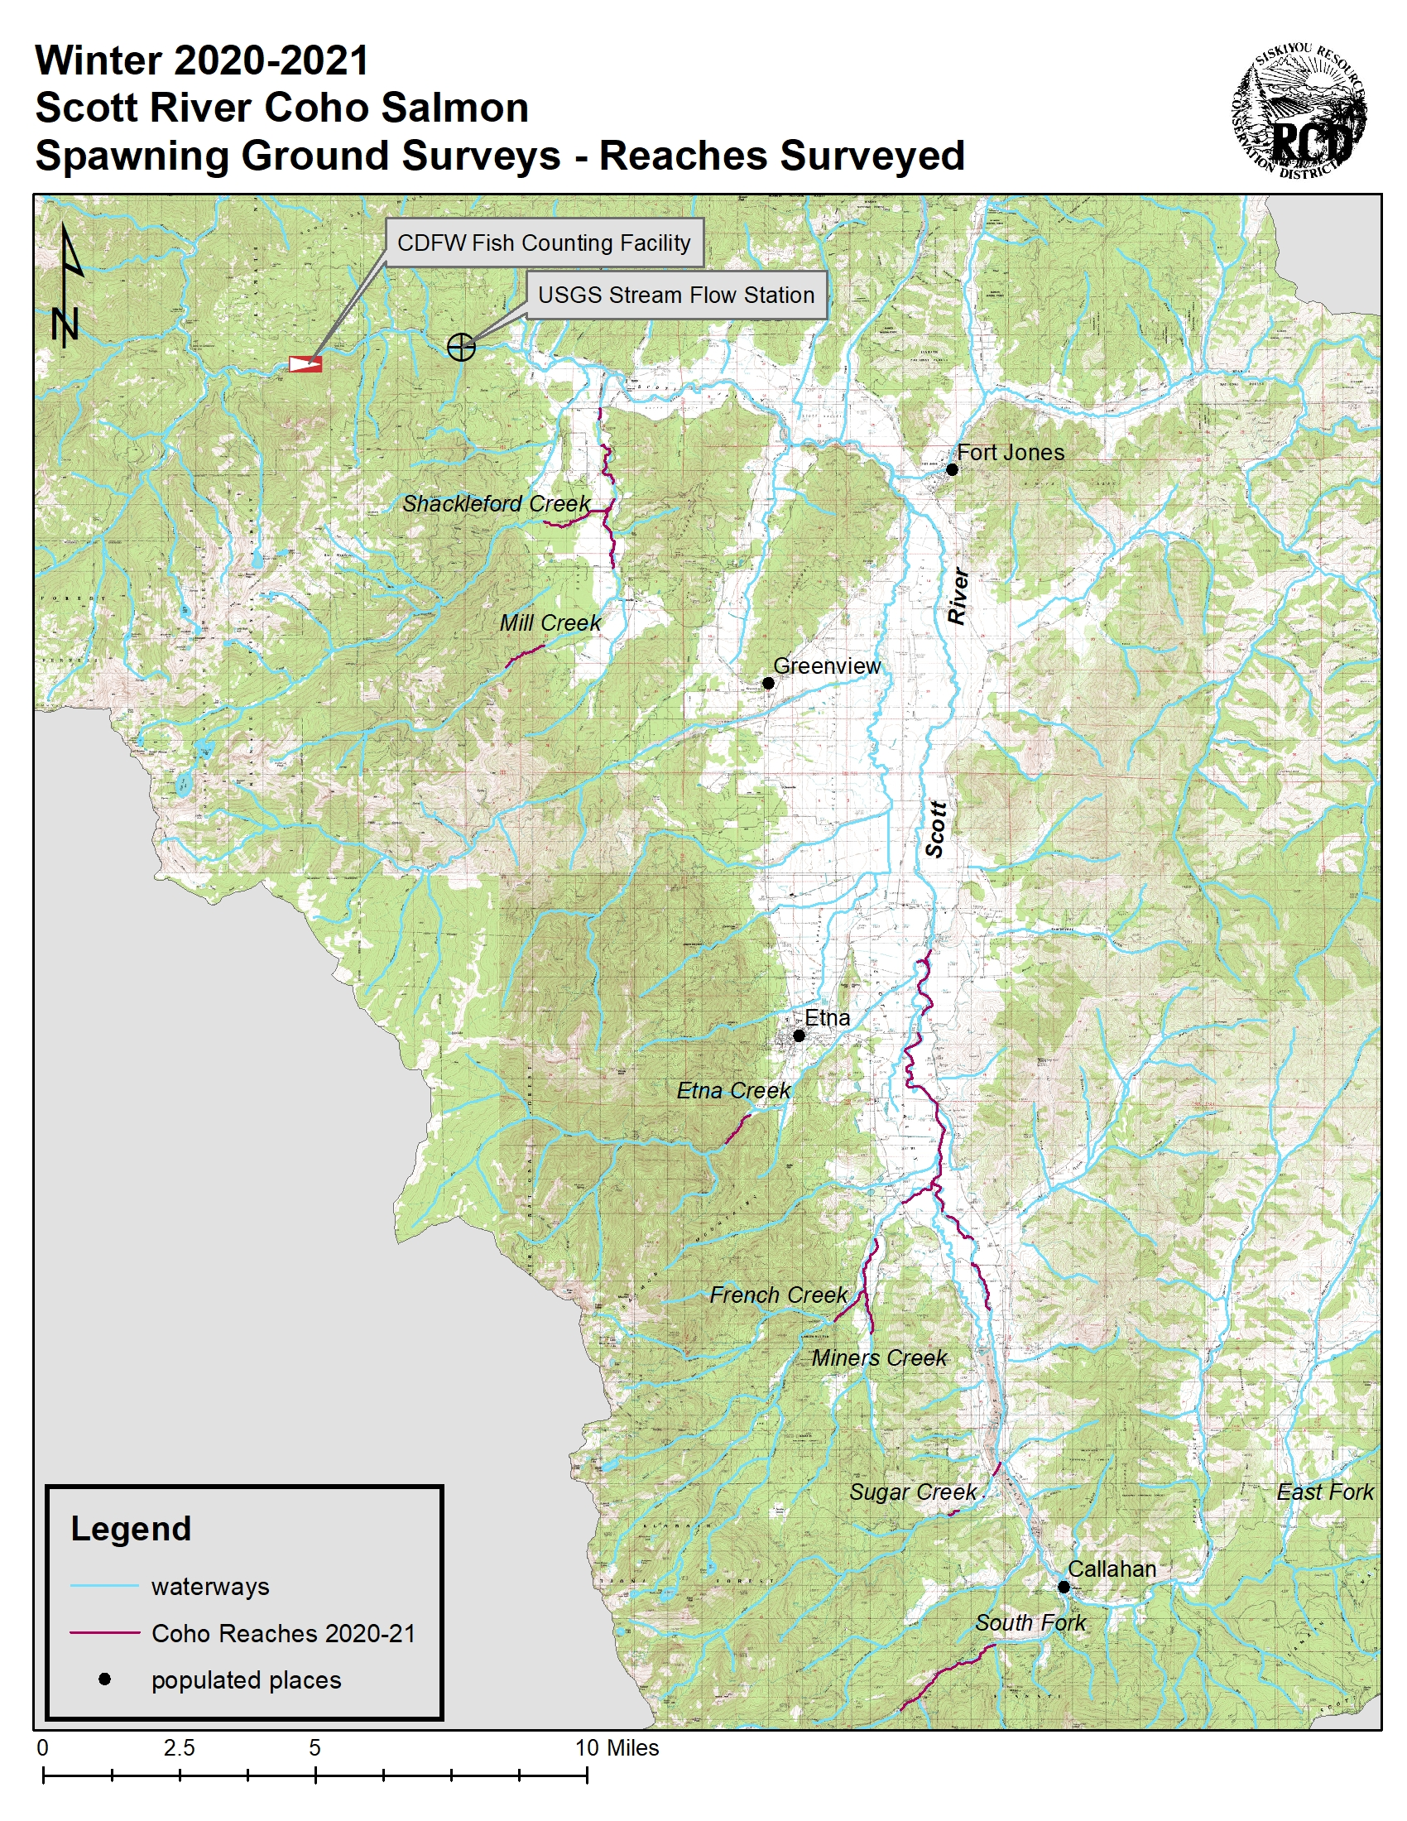
Map 1. Scott River Index Reach Boundaries and tributary reaches surveyed (Siskiyou RCD)

Crew Training

Crew training was organized by CDFW and the Siskiyou RCD. The Scott River Annual Spawning Ground Survey Training was held on December 1st, 2020, at the Siskiyou RCD office in Etna. Training items that were covered included fish species identification, sampling techniques, redd identification, GPS protocol and completing data sheets. All Siskiyou RCD crew members participated in this training or had attended one in past years and had experience doing these surveys. All new field technicians were accompanied by experienced surveyors.

Survey Timing

Following a critically dry 2020 water year, October 2020 began with very few small, intermittent rain events and seasonably cool early fall temperatures. By mid-December, the Scott River was still fully disconnected in upper reaches of the valley, meaning the river was disconnected through the entire baseflow period. These conditions limited adult salmon access to the upper reaches of the valley spawning grounds. The first notable precipitation/flow event, which helped connect several western tributaries, occurred on December 7th through 8th. The upper reaches of the mainstem, including Reach 16, connected on January 4th, 2021, which also allowed migrating fish access to the East and South Fork of the Scott River.

The first observation of adult coho migrating through the SRFCF (located in the canyon reaches downstream of the valley) occurred on November 16th, 2020, with the last coho passing through on January 4th, 2021. On November 25th, 2020, Siskiyou RCD employees made the first observation of adult coho in the valley reaches, with a single individual identified in the lower portion of Reach 9 of the mainstem Scott River. The last observation of live fish made by Siskiyou RCD staff occurred on January 10th, 2021, on Reach 16 of the main-stem Scott River. Surveys continued beyond the third week of January until no live fish were observed for the previous week.

GPS Data Collection

Hand-held Global Positioning System (GPS) units were used to record the location of each redd observed and carcass recovered. Each documented redd and carcass was assigned a unique identifying code based on the stream and reach, date, and sequential number. The unique identifying code was used to label GPS coordinates in the hand-held unit so that this information could be tied back to the data sheets. GPS coordinates were taken in NAD 83 datum and recorded on data sheets in decimal degrees.

Example: SU 112020 L R07 = Sugar Creek, November 20th 2020, Lower Reach, Redd Site #7

Boulder Cr. (South Fork) | BO
Boulder Cr.(Scott) | BS
Canyon Cr. | CA
Clark Cr. | CL
East Fork Scott | EF
Emigrant Creek | EM
Etna Cr. | ET
French Cr. | FR
Grouse Creek | GR
Horse Range Cr. | HR
Indian Creek | IN
Johnson Creek | JO
Kangaroo Cr. | KA
Kelsey Channel | KC
Kelsey Creek | KE
Kidder Creek | KI
McAdams Cr. | MC
Meamber Gulch | ME
Middle Creek | MI
Mill Cr. (Scott Bar) | SB
Mill Creek | ML
Miners Cr. | MI
Moffet Creek | MO
North Fork French | NF
Patterson Creek (Scott) | PS
Patterson Creek(Etna) | PA
Rattlesnake Cr. | RA
Ruffy Gap Trib | RU
Shackleford | SH
Shackleford-Mill | SM
South Fork Scott | SF
Sugar Creek | SU
Thompkins Creek | TO
Wildcat Cr. | WI
Wooliver | WO
Scott River Tailings TA
Scott River Mainstem Index Reach S## (Example – S08 = Scott Reach 8)

Sample Collection

A Federal Endangered Species Act Section 4(d) collection permit from the National Marine Fisheries Service (NMFS) was held by the Siskiyou RCD for biological sample collection from salvaged coho carcasses. The Siskiyou RCD also maintained a current California Endangered Species Act Memorandum of Understanding with CDFW for this effort.

Three sets of scale samples were taken from each carcass. The preferred location for scale collection is above the lateral line between the posterior insertion of the dorsal fin and the anterior insertion of the anal fin. Scales were collected after cleaning the area with a knife. Each set of scales was placed between absorptive paper and into a separate sample envelope and labeled with the unique identifier code that matches the GPS coordinates of its recovery. Sample envelopes and data sheets also record specific information about the carcass, including species identification, fork length measurement (cm), sex determination, and a check for hatchery markings.

Tissue sampling of coho salmon carcasses was conducted in accordance with the protocol established by the NMFS, Southwest Fisheries Science Center, Santa Cruz Laboratory. A pair of tissue samples was taken from each carcass by clipping, with a hole-puncher, two disks from the operculum tissue (gill plate). The tissue samples were placed between absorptive paper and placed in one of the sample envelopes, which also contained one of the scale samples. The envelope was labeled with information about the carcass, as described above, as well as the sample contents: Tissue + Scales.

At least one otolith was collected from each coho carcass with an intact head. A sharp knife was used to section the cranium by making a transverse cut from the dorsal side of the head to roughly above the posterior edge of the preopercular margin, revealing the otic capsule. Otoliths were carefully withdrawn using forceps, placed between absorptive paper and placed in one of the sample envelopes, which also contained one of the scale samples. The envelope was labeled with information about the carcass, as described above, as well as the sample contents: Otolith + Scales.

In total, there were three sample envelopes assembled for each carcass: one with only scales, a second with tissue and scale samples, and a third with otolith and scale samples. All tissue, scale and otolith samples were submitted to the CDFW Yreka Fisheries Office for distribution to individuals performing further analysis. This included staff of the NMFS, Southwest Fisheries Science Center, Santa Cruz Laboratory. All coho carcasses were scanned for passive integrated transponder tags before being returned to the stream.

Species, Gender and Origin Identification

Positive identification of coho salmon is a crucial step in the collection of reliable data from the spawning ground surveys. All field technicians who participated in the surveys this season were experienced at distinguishing between anadromous salmonid species. Several characteristics were used to identify salmonid species in the field including size, body morphology, markings, coloration, behavior, run timing, and geographic location. Suspected coho redds encountered in the absence of spawning fish were distinguished from other species’ redds by a combination of the dimensions, gravel size and habitat characteristics.

The sex of carcasses was verified by squeezing the anal opening to check for the release of milt (male) or eggs (female) or by slitting the abdomen to examine the reproductive organs. Prespawn mortality in females was determined by the visual presence of approximately 100 or more eggs.

Hatchery markings are distinct for both species of salmon present in the Klamath River system. Hatchery Chinook lack an adipose fin while hatchery coho have a maxillary clip (right maxillary clip = Trinity River Hatchery, left maxillary clip = Iron Gate Hatchery). Any hatchery marked carcasses encountered have the snout removed and submitted to the CDFW Yreka Fisheries Office for recovery of the coded-wire tag.

RESULTS

Flow Conditions and Access, Run Abundance and Timing

The Scott River Fish Counting Facility (SRFCF) was installed and began operation on September 28th, 2020, and remained operational through January 4th, 2021. Despite low flow, the Scott River remained connected from the mouth through the valley reaches over the fall of 2020, with the exception of Reach 9 (one of the lower reaches in the valley) and the historic mine tailings within Reach 16 at river mile 55.0 (upper reaches of the mainstem). The river at Reach 9 (river mile 26) didn’t become connected until November 15th, 2020. The connection through the tailings was somewhat intermittent through the first week of January. This intermittent connection may have potentially limited spawners’ access to the upper reaches of the watershed and tributaries, such as Sugar Creek and the East and South Forks of the Scott River. According to the USGS gage at river mile 21, river discharge increased from 66 cfs to 152 cfs on December 7th, peaked at over 300 cfs on December 8th, and remained over 100 cfs through January (Figure 1; USGS, 2019). Despite this initial pulse that provided connectivity through the tailings reach, there remained limited connectivity to some western tributary spawning grounds through the remainder of the run.

The aforementioned mid-December rain event appears to have prompted the coho run into the valley reaches of the Scott River. The SRFCF recorded upstream movement of adult coho from November 15th through January 4th, with the majority of fish (77%) passing through for three days in mid-December (Knechtle and Giudice, 2021). Consistent with this timeframe, surveys were initiated on November 25th on Reach 9 of the mainstem Scott River encountered the first coho salmon documented in the valley (Appendix II. List of Coho Surveys Completed). It is hypothesized that fish had already entered lower valley tributaries such as Shackleford Creek by this time. From mid-December through late January, streamflow remained relatively stable (Figure 1), and coho spawning was regularly documented across the watershed.

The migrant weir was operated through January 4th, 2020, after which it was dismantled due to a lack of migratory action and in anticipation of high flows. A preliminary total of 1,754 coho had been recorded passing through the SRFCF over the season, with the bulk of the returning coho (77%) passing through the video weir December 17th through December 19th (Knechtle and Giudice, 2021), immediately following the flow event. The first coho to be observed by surveyors was on November 25th, the bulk of the live coho observed were seen in the valley tributaries between December 17th and December 30th, 2020. The last live coho that were observed by crews were documented on January 18th, 2020 on Lower French Creek of the Scott River (Appendix II). Surveys continued to be completed for two more weeks to collect carcasses, minimal observations were made, and the last flags were pulled January 20th, 2020.

Carcasses

A total of 78 coho carcasses were recovered from December 2nd, 2020, through January 18th, 2021 (Tables 2 and 3; Appendix II. List of Coho Surveys Completed). Two carcasses were observed but could not be recovered for sampling; all the rest were recovered for sampling (Table 3). The majority of carcasses (27) were found on the middle reach of Shackleford Creek. The recovered carcasses had fork lengths that measured between 51 and 73 cm (Table 3). Applying the maximum grilse fork length cutoff of 56 cm (Knechtle and Giudice, 2020) only two of the carcasses were considered to be grilse (single sea winter salmon as opposed to multi sea winter salmon). No evidence of prespawn mortality was identified in any of the female carcasses. Scale, tissue, and otolith samples were taken from all coho carcasses with the exception of two that could not be sampled due to predation. All coho carcasses were scanned for passive integrated transponder tags, and one was found on the lower reach of Miners Creek by our cooperators at Scott River Watershed Council. None of the recovered carcasses displayed hatchery markings. Following active spawning and carcass recovery from mid-December through mid-January, no new carcasses were found.

Table 2. Summary of Survey Observations by Stream
Stream | Redds |  | Carcasses
Scott River mainstem | Number | Percentage | Number | Percentage
Reach 16 | 30 | 10.6% | 1 | 1.3
Reach 15 | 33 | 11.7% | 3 | 3.8%
Reach 14 | 0 | 0% | 0 | 0%
Reach 13 | 1 | 0.35% | 0 | 0%
Reach 9 | 5 | 1.7% | 1 | 1.3%
Reach 8 | 0 | 0% | 0 | 0%
Scott River mainstem Total | 72 | 26% | 5 | 6%
Tributaries (North to South)
Mill Creek | 55 | 20% | 17 | 22%
Shackleford Creek | 67 | 24% | 27 | 35%
Miners Creek | 30 | 10% | 15 | 19%
French Creek | 56 | 20% | 14 | 18%
Sugar Creek | 0 | 0 | 0 | 0
South Fork | 0 | 0 | 0 | 0

Total Redds= 280
Total Carcasses= 78
Total Live Fish= 466

Table 3. Inventory of all recorded coho carcasses.

Redds

A brief description of the coho spawning observations on the mainstem is presented here, followed by each of the tributaries ordered from North to South. Positional information was gathered for all 280 coho redds observed by surveyors, as presented in Maps 2-5. Figure 2, below, shows the density of redds observed per mile of stream.

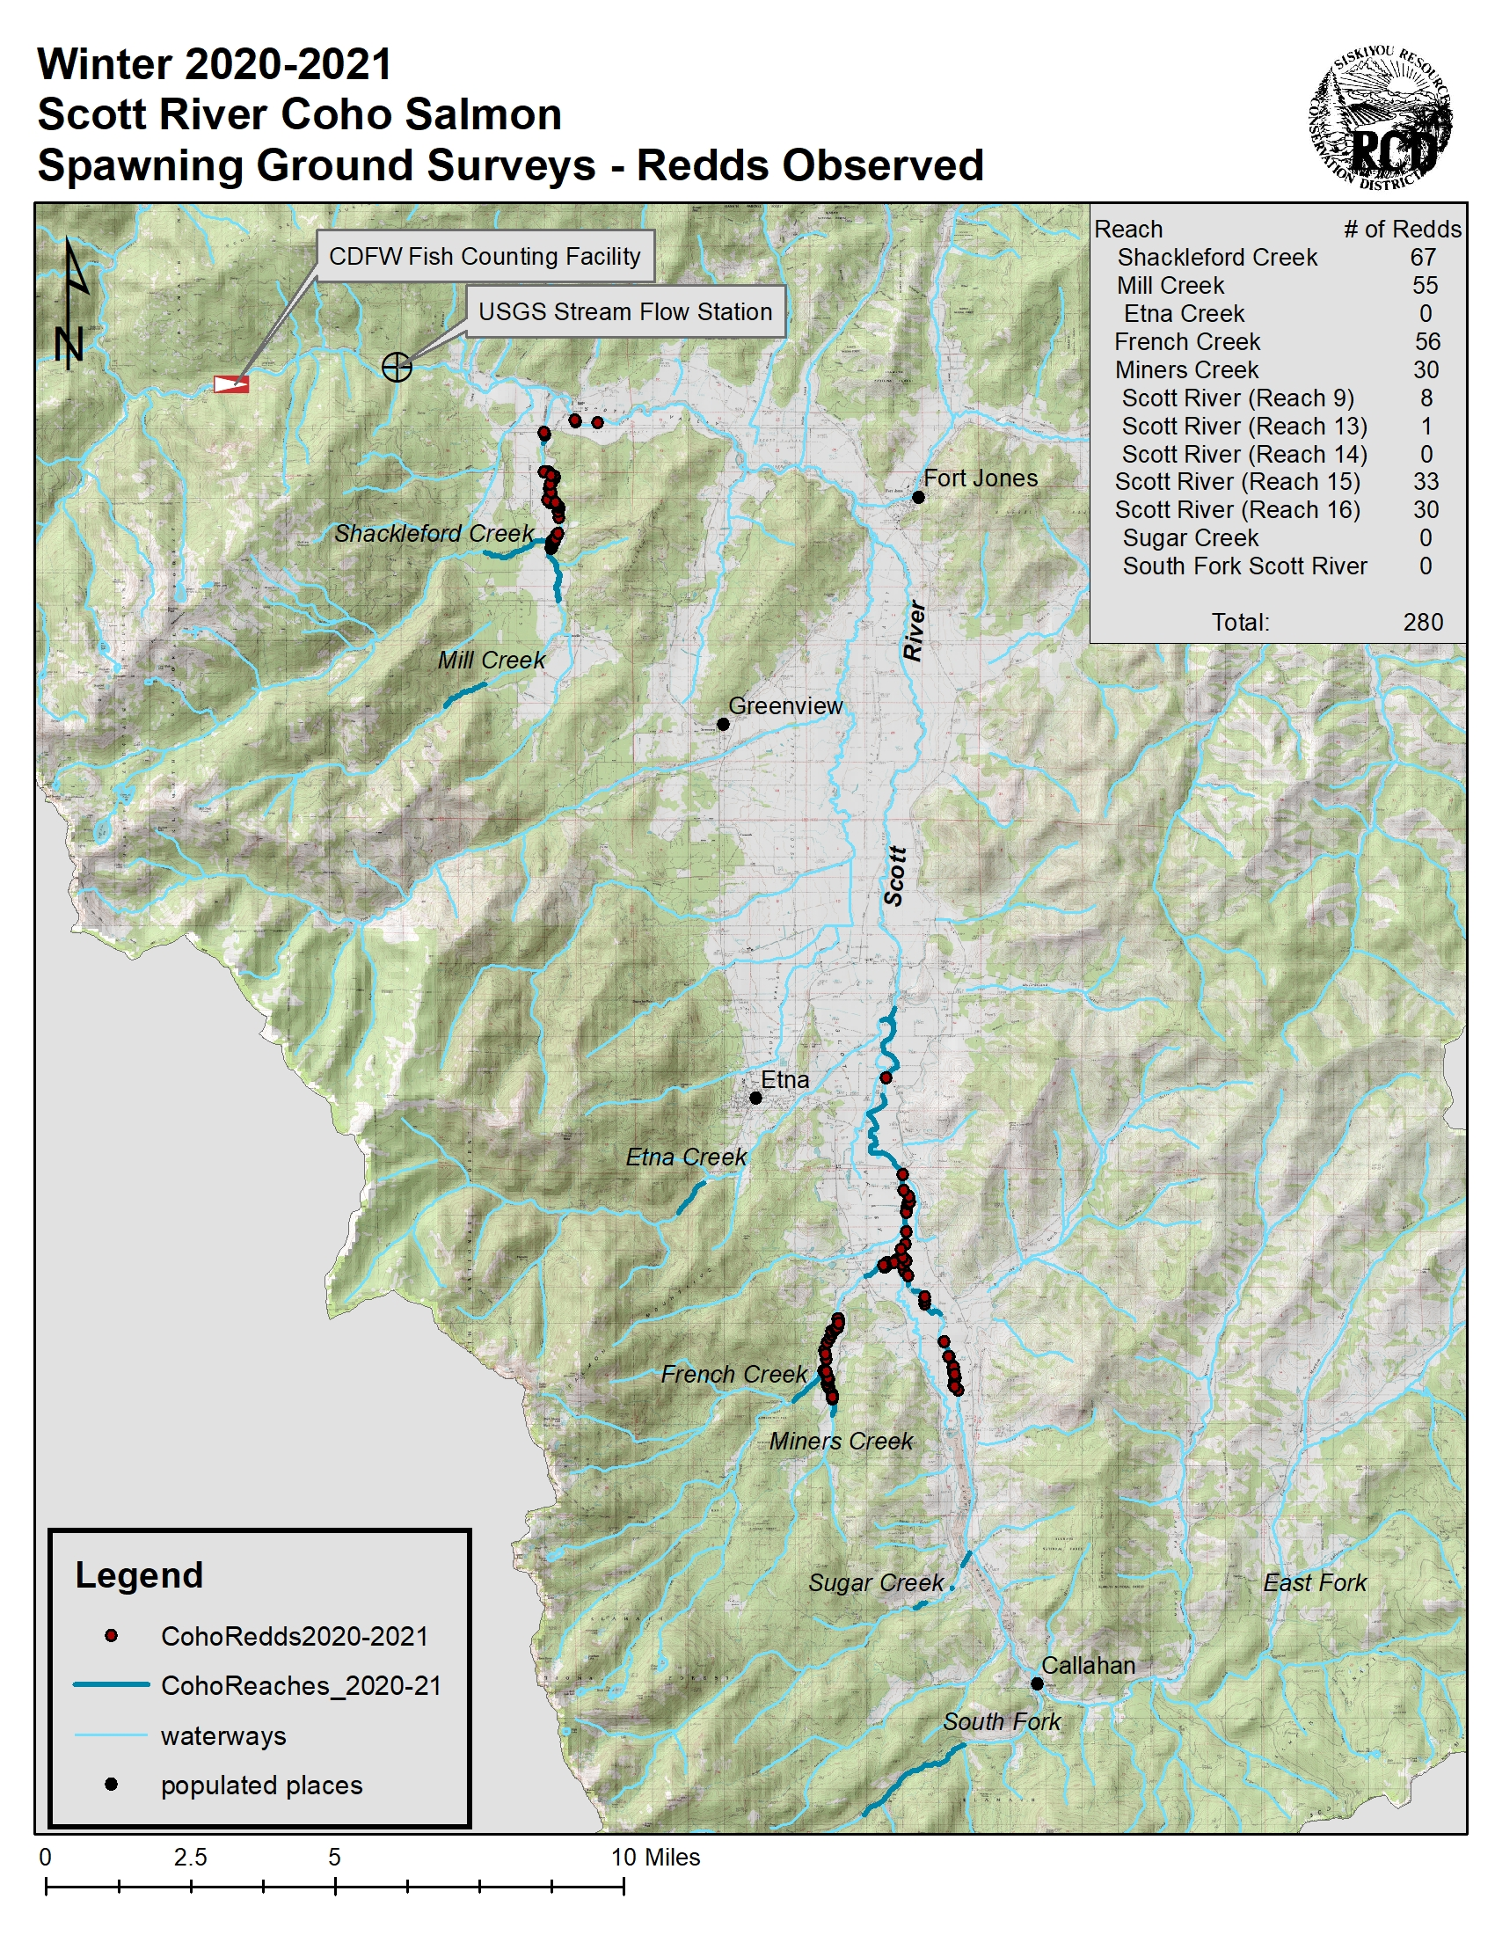
Map 2. Locations of identified coho redds throughout the Scott River watershed (Siskiyou RCD, 2021)

Mainstem Scott River

Over the season, coho spawning was observed on the mainstem of the Scott River on reaches 9, 13, 15, and 16. This is very much in contrast to previous years, when coho spawning on the mainstem was limited to a single reach. Coho spawning observed on the mainstem normally tends to occur along stream margins or side-channels with smaller diameter substrate, but this year coho redds were observed in mid-channel locations lacking the typical cover coho seek for spawning. A total of 72 coho redds were documented in these areas from December 9th, 2020, through January 12th, 2021. The highest number of redds were observed on reach 15 but the greatest density of redds (redds per mile) was observed on Reach 16 from the Fay Lane bridge upstream approximately 1.1 miles (Map 2, Map 3, and Table 2).

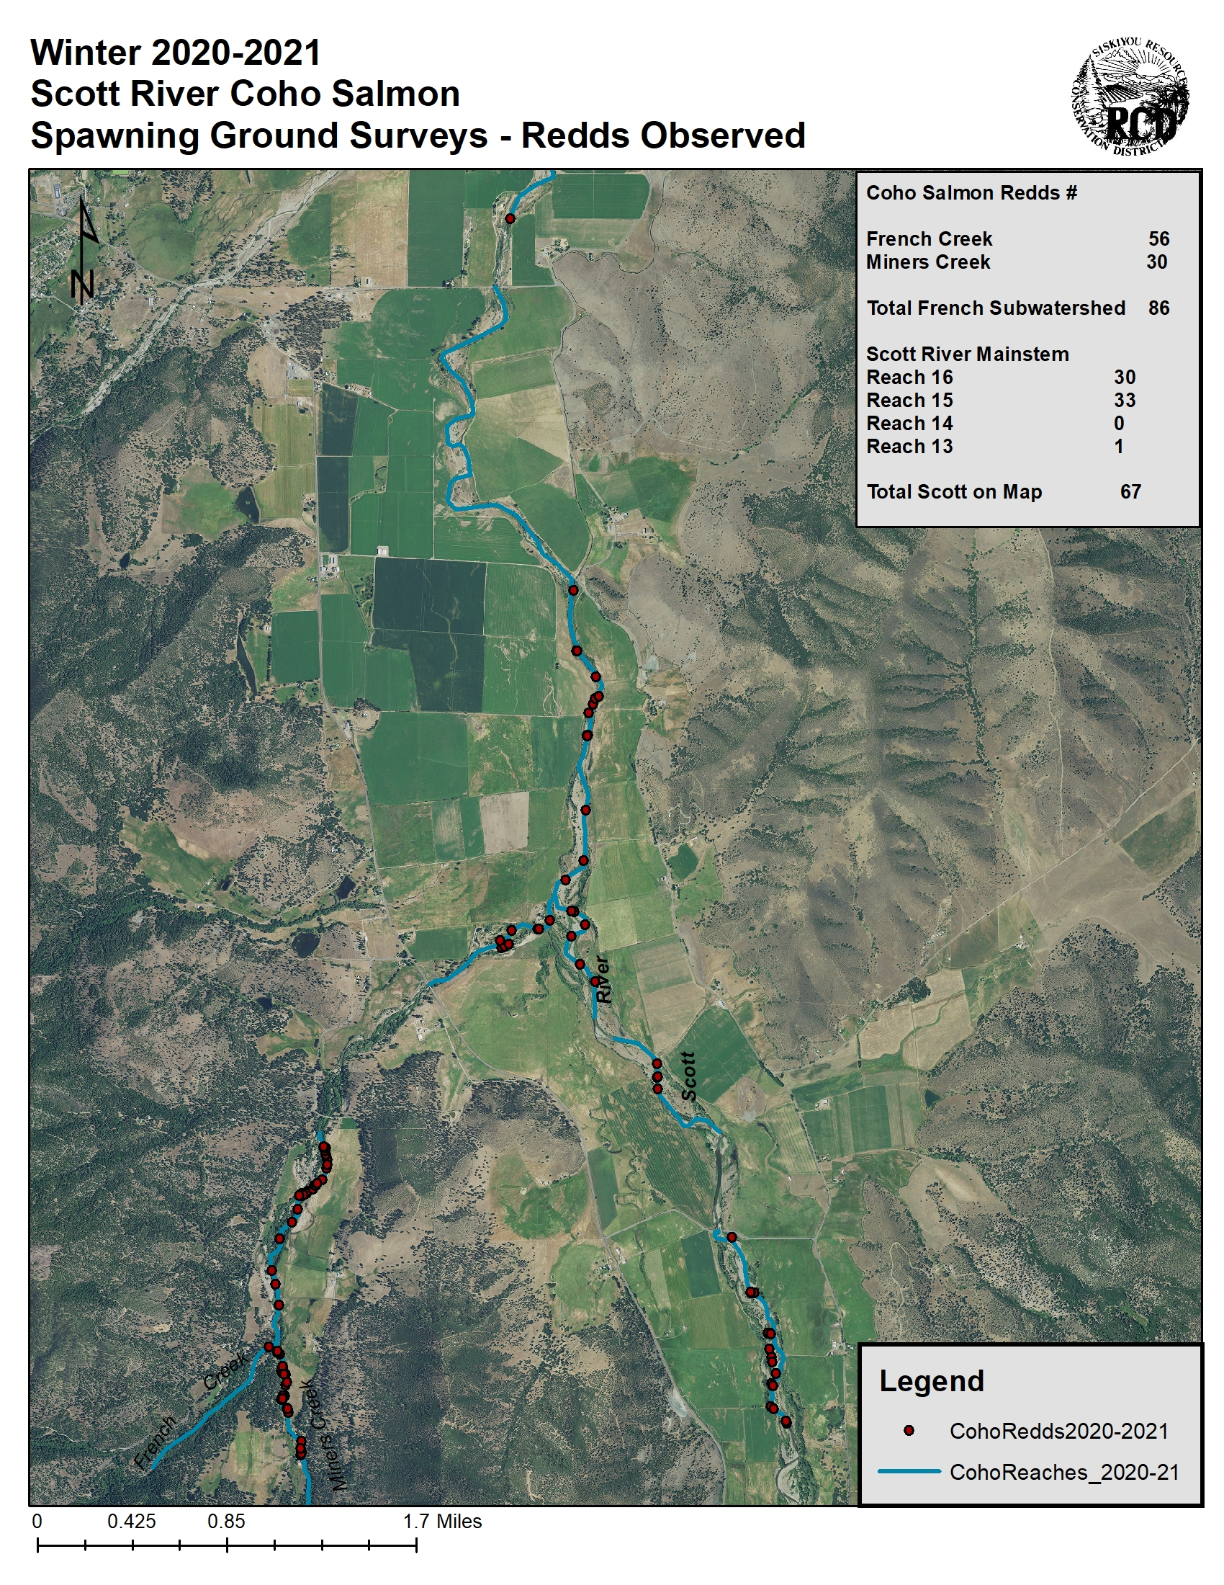
Map 3. Locations of identified coho redds for the Scott River mainstem, along with French and Miners Creeks (Siskiyou RCD, 2021).

Shackleford Creek and its tributary Mill Creek

Shackleford Creek, and its primary tributary Mill Creek, are known to be well utilized by anadromous fish. Initial surveys conducted on December 4th, 2020, revealed four coho redds on lower Mill Creek and twelve redds on Middle Shackleford Creek. New coho redds were consistently documented on both streams through the first week of January, 2021, after which observations of new redds diminished rapidly. A total of 67 redds were documented on Shackleford Creek and 55 redds on Mill Creek (Table 2, Map 2, Map 4). This represented 24% and 20%, respectively, of the total redds observed in the valley reaches. Redds were concentrated in certain areas of each creek where there was an abundance of suitably sized gravels. In Shackleford Creek, spawning was observed in the middle reach but not the upper reach. No surveys were completed on the lower reach due to a lack of landowner access. In Mill Creek, spawning was observed in the lower reach only; no spawning was observed in the upper reach and there were no surveys completed in the middle reach due to a lack of landowner access. Surveys on both Shackleford and Mill Creek led to identification of the upstream extent of spawning. There were nine beaver dams on Mill Creek. The most substantial beaver dam in the lower reach of Mill Creek was the most downstream dam. Redds and live fish were not observed upstream of that dam, so it was determined to be a potential fish passage barrier.
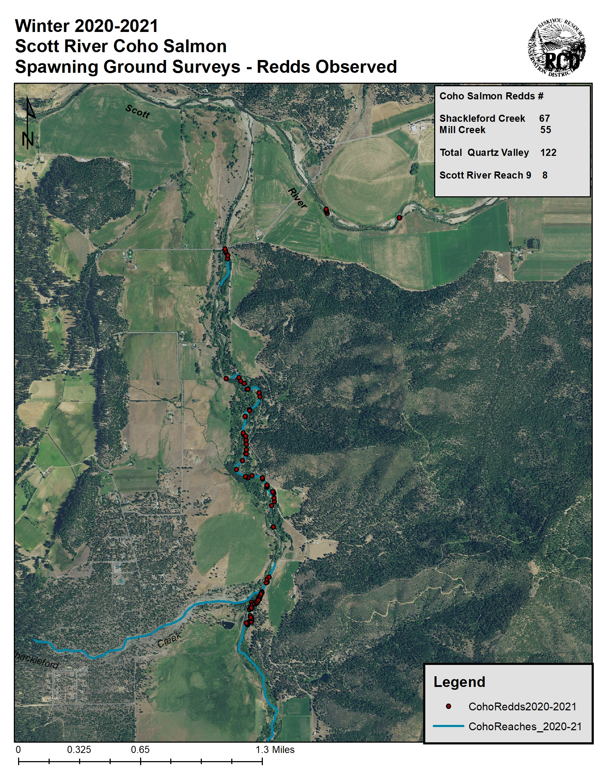
Map 4. Locations of identified coho redds for Shackleford and Mill Creek (Siskiyou RCD, 2021).

French Creek and its tributary Miners Creek

An initial survey through the lower reach of French Creek on December 15th, 2020, found no evidence of coho spawning activity. However, the first live coho salmon and redd formation were observed by surveyors on both the middle and lower reaches of French Creek on December 21st, 2020. Subsequently, new redds were consistently documented during the weekly surveys into the third week of January, 2021. There were several established beaver dams within the first river mile of French Creek; however, none had impacted passage because all of the redds observed were documented above the lower dam near river-mile 0.17, and the vast majority redds on French Creek were above the upper dam near river-mile 1.1 (Map 5). The lowest perennial tributary to French Creek is Miners Creek. The first survey on Miners Creek occurred on December 21st, 2020, and continued weekly through January 18th, 2021. Surveys on both Miners Creek and French Creek were able to identify the upstream extent of spawning. A total of 56 redds were documented on French Creek and 30 redds on Miners Creek (Table 2, Map 2 Map 3, Map 5).

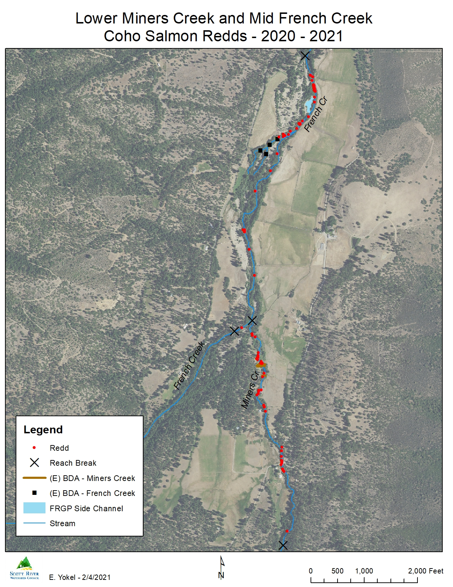
Map 5. Locations of identified coho redds for French and Miners Creek (Scott River Watershed Council, 2021).
Sugar Creek

Surveys on Sugar Creek were initiated on January 7th, 2021, and continued weekly into the third week of January. No redds were observed; however, surveyors observed three live coho. Previous years’ coho spawning ground surveys have documented spawning on the lower and middle reaches of Sugar Creeks, but there were no redds observed during the 2020-2021 season. It is possible that spawning could have occurred in areas where the Siskiyou RCD did not have access. It is also possible that a lack of consistent connectivity with the mainstem Scott River limited fish access and spawning activity.

East Fork of the Scott River and its tributary Grouse Creek

No surveys were conducted during the 2020-2021 spawning ground surveys due to a lack of landowner access resulting from a pending sale of the property.

South Fork of the Scott River

One survey was completed on the middle reach of the South Fork Scott River on January 22nd, 2021. No evidence of spawning was observed, and it is unknown whether adult fish utilized the tributary or simply didn’t migrate up beyond rive- mile 2.3 (the downstream extent of the survey). The number of small private landholdings through Callahan makes access to the downstream portion of this reach infeasible. It is possible that spawning could have occurred in areas where the Siskiyou RCD did not have access.

Kidder Creek and its tributary Patterson Creek

Surveys on Kidder Creek and its tributary Patterson Creek did not occur for the 2020-2021 season as Kidder Creek did not maintain full connectivity with the mainstem Scott River during the time of the surveys.

Etna Creek

Surveys on Etna Creek did not occur for the 2020-2021 season as the creek did not maintain full connectivity with the mainstem Scott River during the time of the surveys.

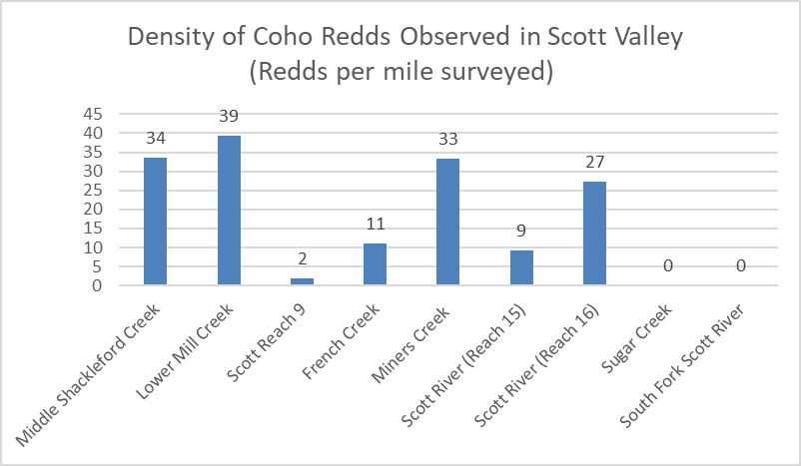
Figure 2: Density of coho redds observed in Scott Valley by tributary (Siskiyou RCD, 2021)

DISCUSSION AND CONCLUSIONS

Data collection went smoothly during the winter of 2020-2021 coho spawning ground surveys. Weather and stream conditions were generally favorable; however, there were some connectivity issues on Reaches 9 and 16 which may have limited some access to Sugar Creek and the East and North Forks. In mid-January, high flows necessitated the cancellation of surveys on Mill/Shackleford Creeks and South Fork.

Since the coho spawning ground surveys were initiated in the Scott River watershed over the winter of 2001-2002, the documented population trends have indicated varying strength among the three cohorts of coho salmon in the Scott River. Between the three cohort cycles, there existed one stronger and two weaker generations. The stronger cohort of 2013-2014 was roughly an order of magnitude larger than the two smaller cohorts (Table 1). The strong cohort has been equalized over time, likely due to a combination of drought and unfavorable ocean conditions. The fish returning in 2020-2021 were the progeny of the 2017-2018 brood year. This brood year was not particularly strong and well below historical averages.

Despite the critically dry conditions, escapement totals and the number of redds observed for the 2020-2021 coho spawning season in Scott Valley were the third highest on record, resetting the trend and establishing a new strong progeny year. As was mentioned above, the previous progeny year of 2017-2018 was not particularly strong and there was no expectation of a strong year of returning salmon due to the aforementioned population patterns and the adverse hydrologic conditions in the Scott River watershed that would not have bolstered the cohort’s numbers. It can be inferred that this unanticipated robust escarpment can be largely attributed to favorable ocean conditions.

The spatial distribution of spawning documented in the Scott River watershed was relatively consistent with previous years. Shackleford Creek and its tributary Mill Creek had the highest density of both redds and carcasses, followed by French Creek, and its tributary, Miners Creek (Table 2 & Figure 2). The upstream extent of spawning was observed on French Creek/Miners Creek, Shackleford Creek/Mill Creek, and on the mainstem, and was consistent with previous years’ observations.

Recommendations

To benefit future surveys, the author that the Siskiyou RCD continue working to maintain positive relationships with landowners and expand access to additional reaches for surveys. Areas of interest might include middle Kidder Creek, middle Patterson Creek, lower Etna Creek, middle Sugar Creek, and middle South Fork.

REFERENCES

California Department of Fish and Wildlife (CDFW) et al. 2015. Cooperative Report of
the Scott River Coho Salmon Rescue and Relocation Effort: 2014 Drought Emergency. Siskiyou RCD, Etna CA. https://www.siskiyourcd.com/resources

California Department of Forestry and Fire Protection (CAL FIRE). 2020. Incremental
Precipitation Quartz Hill Station (QTZ). California Data Exchange Center. http://cdec.water.ca.gov/cgi-progs/stationInfo?station_id=QTZ

California Department of Water Resources (CDWR). 2019. 2019-2020 Water Year
Monthly Precipitation, Fort Jones RS (FJN) and Callahan (CAL) stations. California Data Exchange Center. http://cdec.water.ca.gov/cgi-progs/reports/PRECIPOUT

Jetter , C and Chesney, B. 2016. Shasta and Scott River Juvenile Salmonid Outmigrant
Study, 2016: Final Report. California Department of Fish and Wildlife - Yreka, CA.

Knechtle, M. and Guidice, D. 2021. 2020 Scott River Salmon Studies. Final Report,
Klamath River Project. CDFW Yreka Fisheries Office. Yreka, CA.

Knechtle. M. 2021. Personal communication.

Magranet. 2017. Scott River Adult Coho Spawning Ground Surveys 2016-2017 Season.
Final Report. Siskiyou Resource Conservation District. Etna, CA.

Maurer, S. 2002. Scott River Watershed Adult Coho Salmon Spawning Survey:
December 2001 - January 2002. Prepared for the Klamath National Forest, Fort Jones, CA.

Scott River Watershed Council. 2021. Lower Miners Creek and Mid French Creek Coho Salmon Redds 2020-2021.

Siskiyou Resource Conservation District. 2021. Locations of identified coho redds maps.

Siskiyou Resource Conservation District. 2021. Density of coho redds observed in Scott Valley by tributary chart.

United States Bureau of Reclamation (USBR) 2019. Incremental Precipitation
Scott Mountain Station (SCT). California Data Exchange Center. http://cdec.water.ca.gov/cgi-progs/stationInfo?station_id=SCT

United States Geological Survey (USGS). 2020. Stream Discharge Scott River RM
21 Gage # 11519500, provisional data. http://waterdata.usgs.gov/ca/nwis/uv/?site_no=11519500

Western Regional Climate Center. 2020. Northern California RAWS Daily Precipitation Callahan station. https://raws.dri.edu/cgi-bin/rawMAIN.pl?caCCAL

Yokel, D. 2014. Scott River Adult Coho Spawning Ground Surveys 2013-2014 Season.
Final Report. Siskiyou Resource Conservation District. Etna, CA.

Appendix I: Length of Stream Reaches Surveyed

Appendix II: List of Coho Surveys Completed

